## 

## Dara Phillips

K00276266 IDM2

### **Front-End Development**

RWD Project

**Research & Content Development**

**Inspirational Websites x 4**

1. **Graphical user interface, website

   Description automatically generated**[**OMBE (Ocean Mind Body Equipment)**](https://www.ombe.co/?75476981_page=2)

**What I liked / disliked**

**Layout**

In my opinion, this website is well balanced. From smart phone – Tablet – Desktop the user is getting the same experience, there is no disconnect. It is very responsive and the ratio from readable to image content is ideal.

I like the use of space; the content has room to breathe and the viewer is not overwhelmed with information. It is also well aligned.

One drawback, would be the “Free trial” card that is not possible to clear off of the bottom of the screen (but you can’t blame them for pushing sales or get new users).

**Fonts**

From the get go your eyes meet the large bright ‘SURF WITH’. It is a funky and relaxing font style which suits the surfing ambiance and sets the right tone in my opinion.

However, it does not forfeit any readability and it pairs well with the secondary font.

**Colour scheme**

The use of color on this site works very well. The contrast between the light and dark backgrounds and text allows for everything to be clear and concise. Colours pop in some sections but they also complement the relaxed feel with the primary yellow and pale blue green used throughout.

**Usability**

The site is easily navigated with a lot of familiar features, one being the hamburger menu present in the top left corner of the mobile and tabular viewports.

The navigational bar is pretty standard in the desktop view, displaying dropdown menus and hovers. Interactive buttons that shrink when hovered over are present throughout the website as are animated card images.

The cursor changes to a pointer on relevant items which is helpful.

Lastly, I like the carousel and the indicator circles that are consistent across many websites and increase learnability.

1. Graphical user interface, website

   Description automatically generated[**Magic seaweed**](https://magicseaweed.com/)

**What I liked / disliked**

**Layout**

This site is set up in a well-spaced grid format that utilizes a lot of cards with headline links.

Each feature that the user may wish to access is clearly outlined and it does exactly what it says on the tin without much frills which is my reason for choosing it, simplicity.

Similar to OMBE, a hamburger menu appears when forced to mobile and tabular views.

I like the sites use of graphs, maps, and iconography. All are well aligned and uniform.

**Fonts**

The fonts used have a high legibility but, on the downside, due to the fact there are a lot of headings in uppercase, it can feel like you are reading SHOUTING most of the time.

The sizes used give a clear indication of hierarchy.

**Colour scheme**

In contrast to OMBE the colours chosen on the main page are not my preference. They could have made it more energetic or relaxed. There are a lot of seascape images that are used which give off surfer vibes but there is no relaxed feel. It seems colder.

The content is nevertheless easily consumed.

As you get into the deeper levels of the site, there is a stop light system colour scheme used to alert the user when conditions are good, reasonable or dangerous, I find this helpful.

**Usability**

The website is easily navigated. One thing I would change – The first three items of the landing page nav-bar are snappy drop-down menus, with the remaining four being delayed links which was not a nice user experience.

As you get to the deeper levels of the site there are breadcrumbs which keep the user informed of where they are at all times and how to get back.

Overall, I think the site is familiar, consistent, simple, and satisfies user needs.

1. 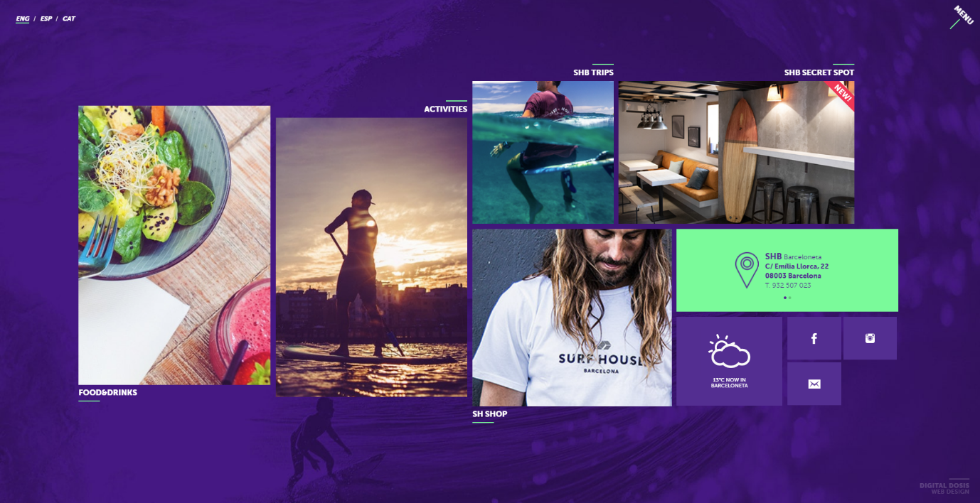 [Surf House Barcelona](http://surfhousebarcelona.com/)

**What I liked / disliked**

**Layout**

This websites layout is in a bunched tiled format. It is simplistic, efficient, and easy to learn. The user doesn’t have to travel far on the page to reach their desired link. There is a good use of white space, and when you have stopped looking at the center tiles you notice to corner content.

The top left of the landing page gives the user a choice of language (English, Spanish or Catalan). It’s a nice touch. In the top right corner, there is a menu button which creates a dropdown of all of the tiles available in word format. It’s a little bit unnecessary and something I would change.

**Fonts**

The size and contrast of the fonts work well. They are highly legible and the hierarchy is clear.

**Colour scheme**

The colours of this page are not usual surfing site choices (blues and greens), but they are good feeling and energetic and the purple, green and white complement one another.

**Usability**

On the mobile and tabular versions of the page they introduce horizontal scrolling between options which is nice instead of endless vertical scrolling on most websites.

At the end of some of the pages the nav bar is at the bottom, this is helpful and efficient.

There are many interactive elements to keep the user focused. These hero images, link hovers, pointers and descriptions. There are also circle indicators to navigate the site.

1. 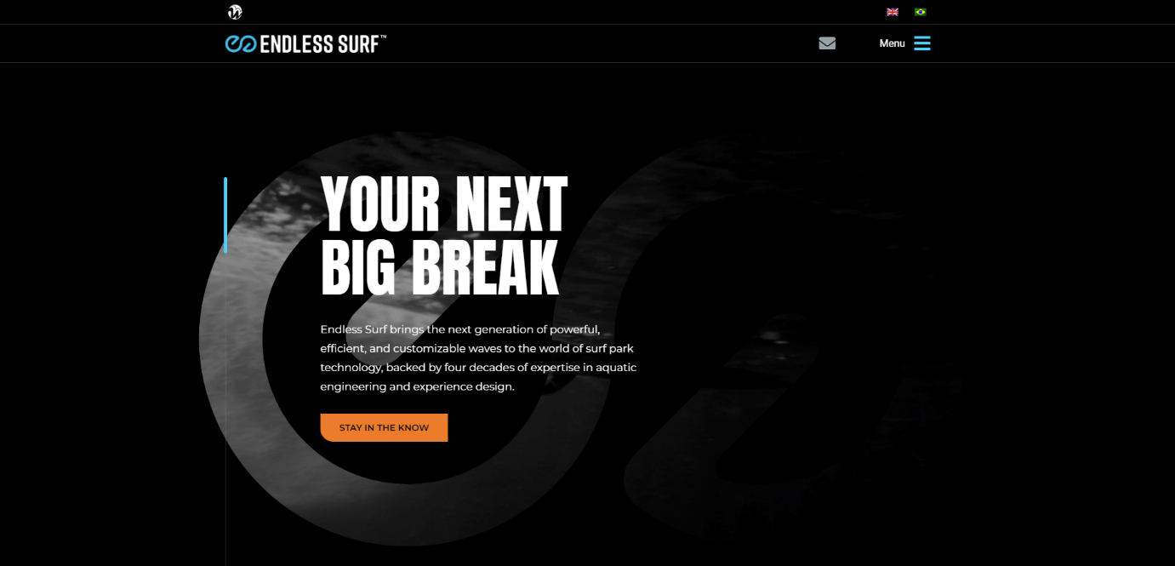 [**Endless Surf**](https://endlesssurf.com/)

**What I liked / disliked**

**Layout**

A great use of space and alignment. Nothing is cluttered or overwhelming.

**Fonts**

Consistent across all pages, it utilizes large bold header text to draw the user in and a subtle secondary text message to explain the goal and content of the current page.

**Colour scheme**

I really like the colour choices, the dark background lets the brighter colours pop and drive the users eye around the page. It’s consistent throughout.

**Usability**

On the desktop viewport there is a nifty blue scroll bar with a description on the left side of each page which shows the user exactly where they are, and what they are reading.

The site is easily navigated. There is a quick language toggle option for English / Brazilian in the top right corner as well as a hamburger menu which slides in nicely from the right horizontally to reveal all options.

The tablet and mobile version of the site use the card format but horizontal scrolling is also used which is a good break from vertical only scrolling. Overall it’s simple to use and easily learned.

**User Stories x 10**

1. - “I want to be able to check the timing of the tides”
2. - “Be able to learn about different types of surfboards”
3. - “Register for the sites news letter to stay up to date”
4. - “Be able to learn about different types of waves”
5. - “I want to be able to see the wind direction and forecast”
6. - “I want to read about tips for new surfers (Beginners)”
7. - “To use the site to book a surf lesson”
8. - “Shop a buy online merchandise”
9. - “See statistics on wave forecasts for the coming 7 days”
10. - “View videos of professional surfers in action”

**Why I chose my colour scheme**

The following bullets outline the process I used to determine my website colour scheme;

* Looking a natural inspiration regarding my concept (surfing) like seascapes and surfing equipment
* Researching similar websites and taking into account the colours they used and how they influence my feeling towards the site
* Experimenting with free palette websites such as; [Adobe colour wheel](https://color.adobe.com/create/color-wheel) and [Color Hunt](https://colorhunt.co/)
* Trying to match a colour palette with the impression or vibe I want the user to feel from using my site, that being either energetic or ‘chill’ moods
* Using the 60 – 30 – 10 rule ( Primary, Secondary and Tertiary)
* Experimenting with different palettes on a single design to observe the contrast and see what works, what doesn’t, and why

### RWD P

### Experiment to choose logo and colour scheme**Experiment to choose logo and colour scheme**

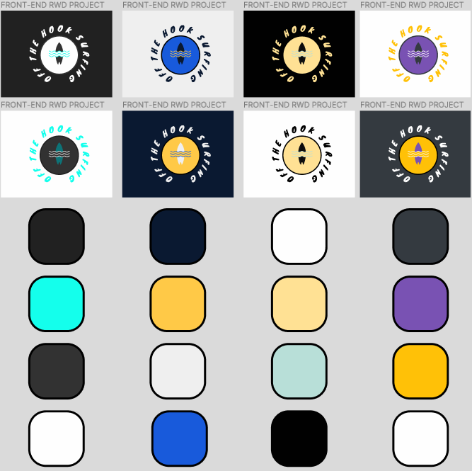 **Experimenting with different palettes**

**Moodboard .png**